EN. 605-702

Project 1: RouteMe

Benjamin Huang

## Business Use Case:

This application stores a list of customers and addresses in a database and allows the user to optimize their route. The user can select which customers they need to visit so that they can be added to their route. The user can edit the route list by clearing the list and re-selecting the customers. With a potential list of customers selected, the user can generate the optimal route which is powered by Google Map API. The user can add more customer addresses through the form at the bottom of the page. The application will use Google Map API to geocode the address into latitude and longitude which is used to generate the optimal route.

Note: The website is live and working as of the writing of this report at <https://benyellow.com/>

## Tech Stack:

The application’s frontend is built using HTML, CSS, JavaScript and is hosted on an S3 bucket in AWS. Cloudflare is used as the CDN cache to distribute.

The application’s backend is built using NodeJS and ExpressJS to create a Data Access Object (DOA) API. When requests from the frontend are received, it routes it through the API to determine what action to take, such as generating a route which requires sending a request to Google Map Route API or sending request to the MongoDB database.

The document-based database is hosted on the MongoDB platform service, and it is used to store customer data. The backend server sends requests to the database to store or retrieve customer data.

To Do:

Implementing AWS SQS. AWS SQS will be added to the backend to handle requests that makes changes to the MongoDB database. The backend API request will forward the incoming request to the AWS SQS which will forward the request to Data Access Object API. Currently this is hosted on the same machine but will be decoupled to implement the AWS SQS.

## AWS Infrastructure Diagram

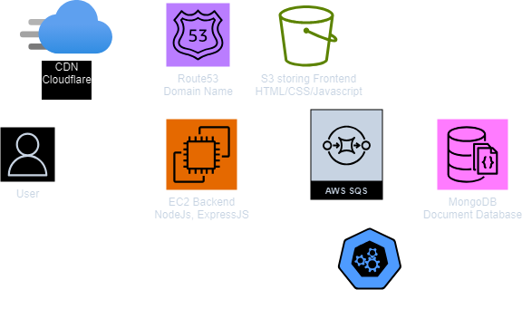

Frontend hosted on S3 bucket and Cloudflare for CDN:  
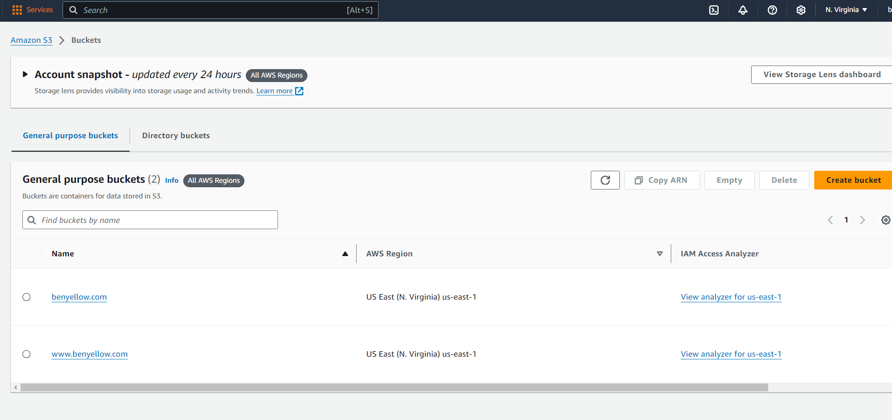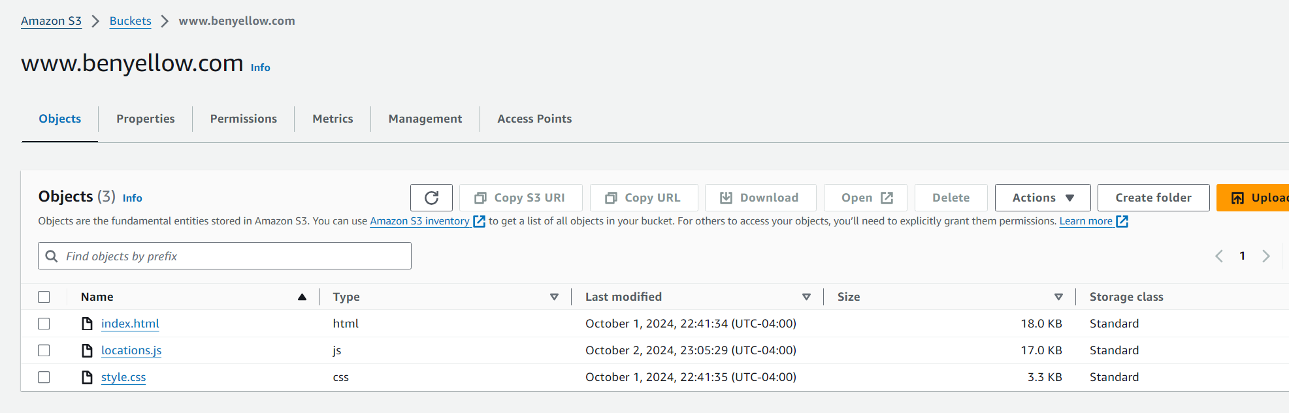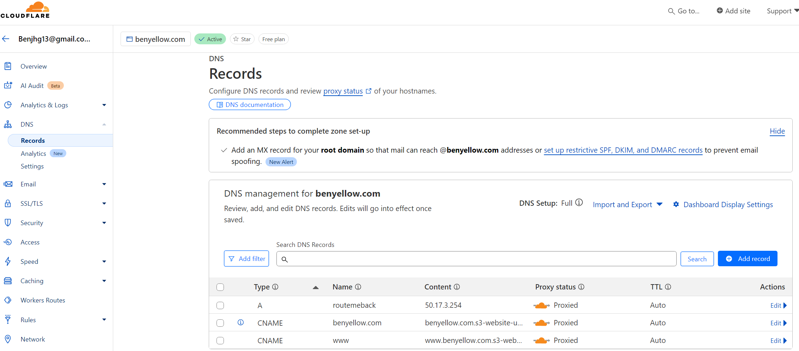

Backend EC2 Instance Details:

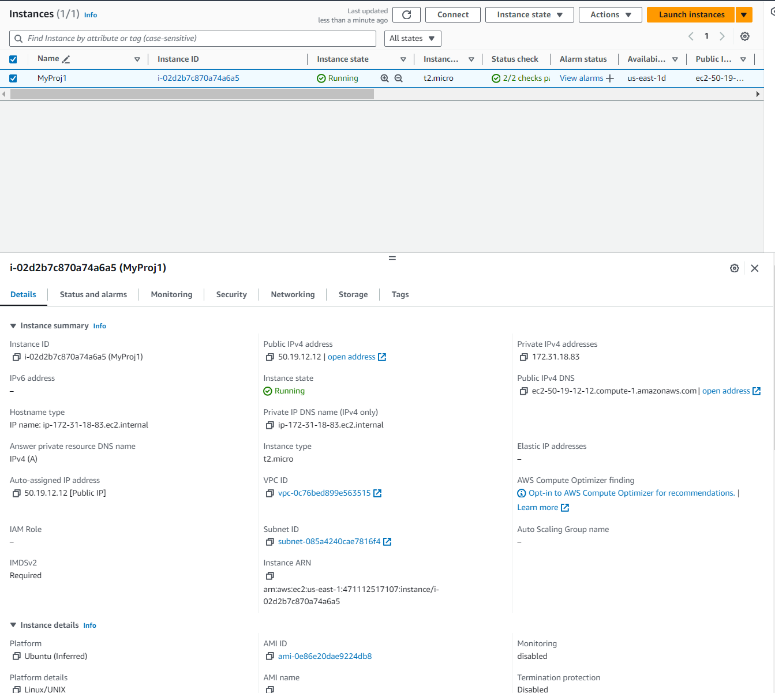

Monitoring

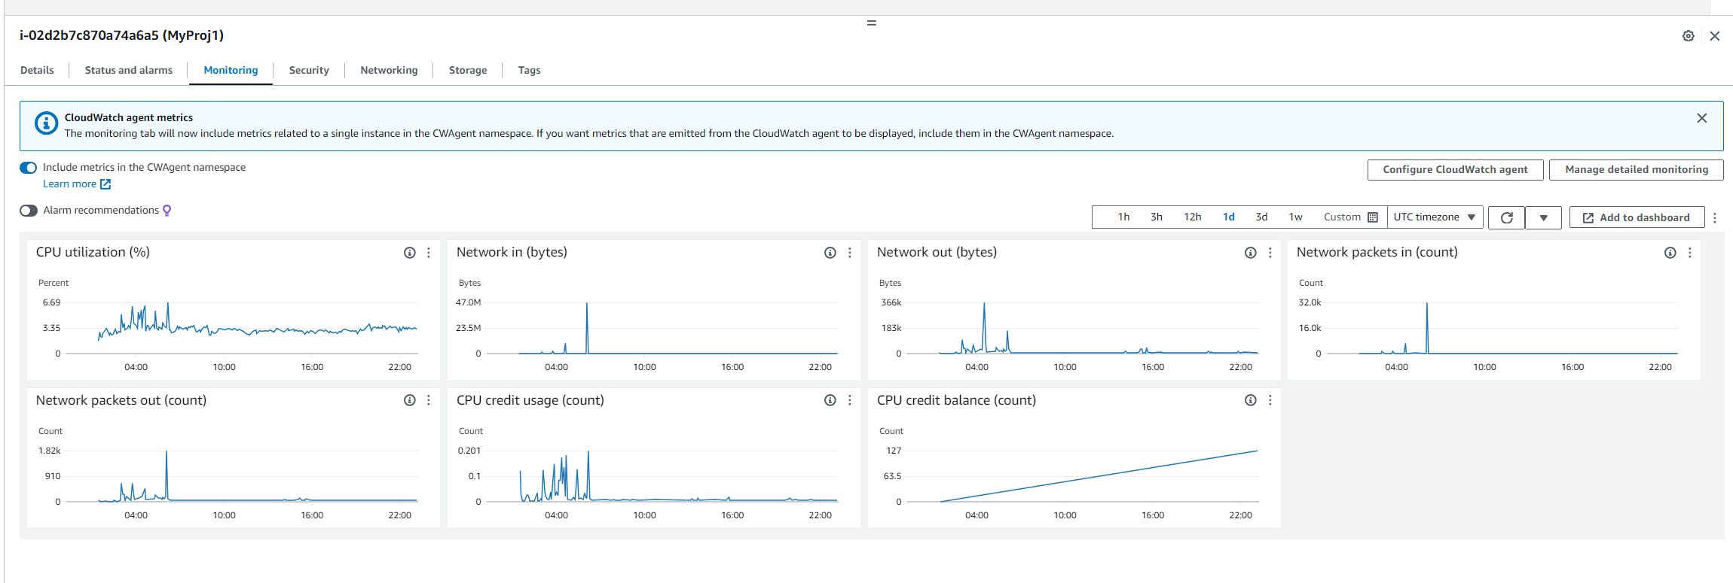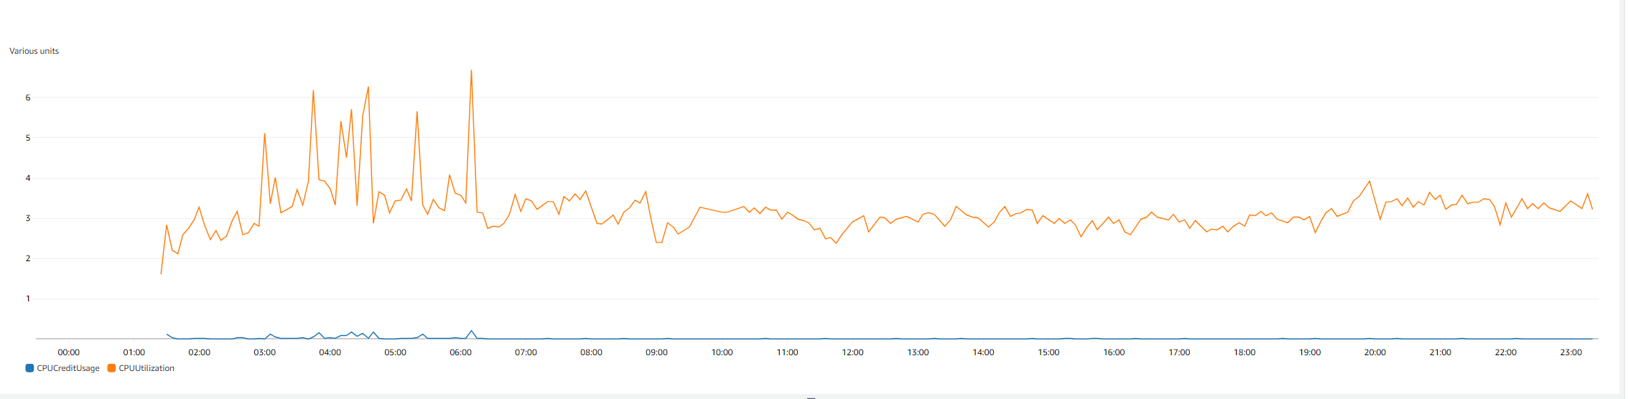

MongoDB Instance:

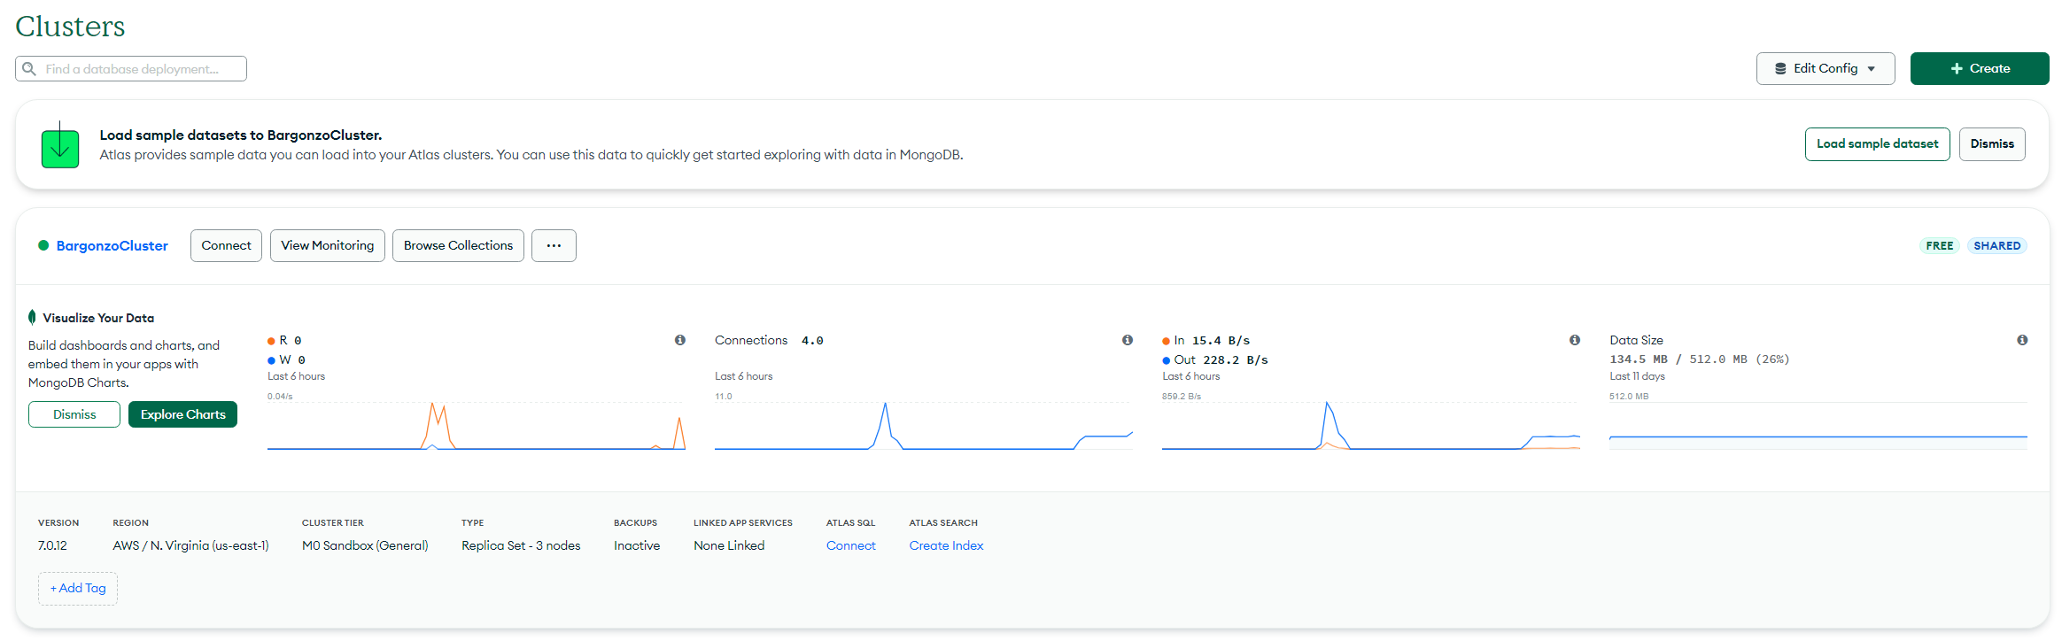

This shows the jhu-myproj1 service running. This is the backend service.

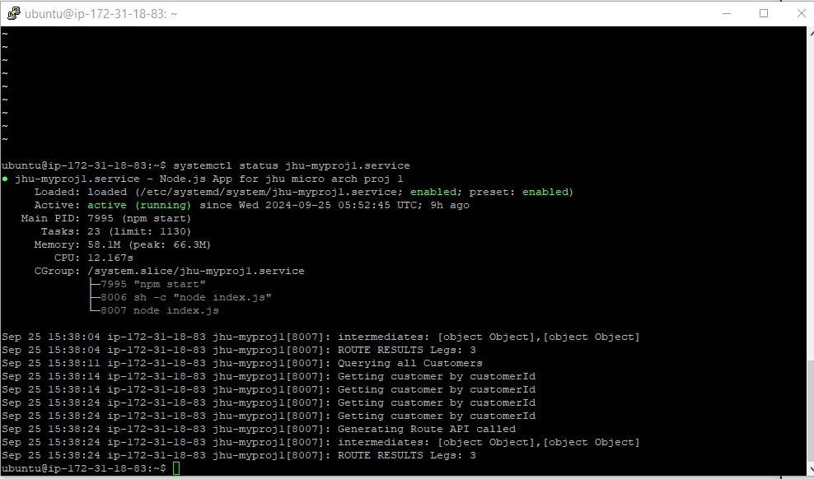

Security Group for backend EC2:

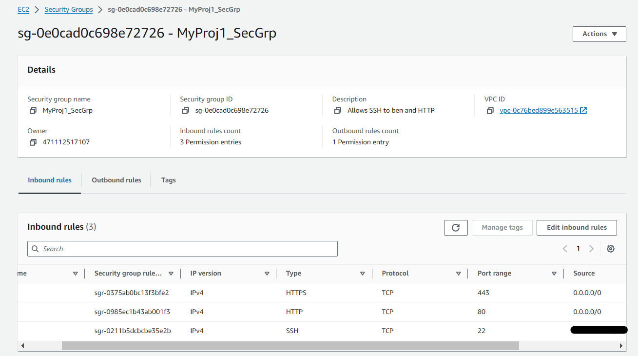

# Demo

1. Opening application by going to the domain name benyellow.com



1. Adding customer address to the potential route  
   
2. Clearing the potential route   
   
3. Generating optimal route   
   
4. Submitting new customer information and creating route with the new customer information  
   